# Links do not have descriptive text

May 2, 2019 • Updated Aug 21, 2019

Appears in: [SEO audits](https://web.dev/lighthouse-seo)

Link text is the clickable word or phrase in a hyperlink. When link text clearly conveys a hyperlink's target, both users and search engines can more easily understand your content and how it relates to other pages.

## How the Lighthouse link text audit fails [#](https://web.dev/link-text/?utm_source=lighthouse&utm_medium=devtools#how-the-lighthouse-link-text-audit-fails)

[Lighthouse](https://developers.google.com/web/tools/lighthouse/) flags links without descriptive text:

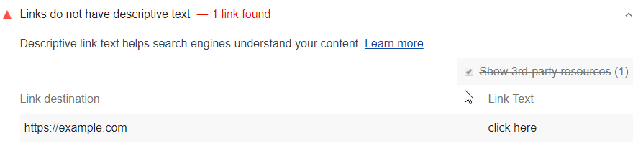

Lighthouse flags the following generic link text:

* click here
* click this
* go
* here
* this
* start
* right here
* more
* learn more

Each SEO audit is weighted equally in the Lighthouse SEO Score, except for the manual [**Structured data is valid**](https://web.dev/structured-data) audit. Learn more in the [Lighthouse Scoring Guide](https://developers.google.com/web/tools/lighthouse/v3/scoring).

## How to add descriptive link text [#](https://web.dev/link-text/?utm_source=lighthouse&utm_medium=devtools#how-to-add-descriptive-link-text)

Replace generic phrases like "click here" and "learn more" with specific descriptions. In general, write link text that clearly indicates what type of content users will get if they follow the hyperlink.

<p>To see all of our basketball videos, <a href="videos.html">click here</a>.</p>

Don't

"Click here" doesn't convey where the hyperlink will take users.

<p>Check out all of our <a href="videos.html">basketball videos</a>.</p>

Do

"Basketball videos" clearly conveys that the hyperlink will take users to a page of videos.

You'll often need to revise the surrounding sentence to make link text descriptive.

## Link text best practices [#](https://web.dev/link-text/?utm_source=lighthouse&utm_medium=devtools#link-text-best-practices)

* Stay on topic. Don't use link text that has no relation to the page's content.
* Don't use the page's URL as the link description unless you have a good reason to do so, such as referencing a site's new address.
* Keep descriptions concise. Aim for a few words or a short phrase.
* Pay attention to your internal links too. Improving the quality of internal links can help both users and search engines navigate your site more easily.

### What Is “Links Do Not Have Descriptive Text”?

Basically, **Google wants every button and link on your site to be hyper-explicit about what it’s going to do for the user**. Here’s how they [describe it](https://developers.google.com/web/tools/lighthouse/audits/descriptive-link-text):

“In general, the link text should clearly indicate to users what type of content they’ll get if they click the link.”

In other words, **the days of the “Learn More” button are over**.

You’ll find this error in the SEO section of your Lighthouse report.

Here’s a bad link that would flag “Links Do Not Have Descriptive Text”:

<p><a href="https://altitudemarketing.com/blog/sustainable-seo-strategy/">Click here</a> to see our post on sustainable SEO.</p>

Here’s a good link to the same content:

<p><a href="https://altitudemarketing.com/blog/sustainable-seo-strategy/">Sustainable SEO</a> is all about delivering a fantastic user experience.</p>

See the difference?

One link is – to Google’s eyes – about clicking here. There’s no context in that. The other is an article about sustainable SEO linked from the words sustainable SEO. Much clearer, and much better.

**The first example would throw the red flag in your Lighthouse score. That means Google is finding an issue with your user experience. And since Google is all about user experience, that could affect your SEO**.

The second example is a good link. It’s fine for Lighthouse, and fine for Google. Don’t be lazy with your links.

#### Which Words Are Out?

According to Google’s Developer Tools, Lighthouse will look for and flag these terms when used as descriptions for links or buttons:

* click here
* click this
* go
* here
* this
* start
* right here
* more
* learn more

See the pattern? All of those apply to pretty much every link in the world. And if you apply to every link in the world, you’re not descriptive.

### Fixing the Descriptive Text Error

Fixing “Links Do Not Have Descriptive Text” is pretty gosh darn easy: **Just replace your link descriptions**.

Lighthouse will tell you which links on the page are bad. Replace the words in the list above with something that is:

* Descriptive
* On topic
* Short and sweet
* Useful for the user

In a lot of cases, this means changing sentence structure like the code examples above. Drop “click here” and “go” from your vocabulary and just put your links in context.

If you have buttons that read “Learn More,” find something better. If you don’t have anything better, do you really need the button?

Anchor text is the descriptive text of an outbound link. It is clickable, and it’s readable to both the user and to search engines.

Every link coming into a website is seen by search engines as a mark of endorsement from the linking website. As far as the search engine is concerned, the more endorsements, the more relevant and trusted your website must be, and thus the higher it would rank in results. How this link is described in the anchor text is considered to be one of the top three ranking factors, and remains an integral part of any content marketing or SEO campaign.

In short, anchor text is a hyperlink to a given information source. In a browser it is usually underlined:

[www.goup.co.uk/guides](https://www.goup.co.uk/glossary/)

Anchor text does not have to show the URL that it is linking to. It can simply describe the destination:

[Online SEO Guide](https://www.goup.co.uk/glossary/)

In the code, it looks like this:

<a href="http://www.yourwebsite.com">Chosen Anchor Text</a>

To optimise an inbound link to positively influence your webpage SEO, there are a number of things to consider when it comes to your choice of of anchor text.

## How to use anchor text

Search engines use anchor text as one way to understand what the linked-to page is about. It is a major ranking factor as the engines consider anchor text to be generally unbiased, user generated information. Because one page can have many different links to it, with many variations of anchor text, the search engines are provided with many differing opinions on the contents of the page.

It goes both ways: There are the SEO benefits of the anchor text to the destination page it is linking to, and the benefit to the page the link is on.

But be warned, since the introduction of [Google’s Penguin](https://www.goup.co.uk/guides/google-penguin/) algorithm, aggressive anchor text that lacks diversity and relevancy can result in ranking penalties for the linked-to site. Here’s Google’s example of content it considers spam:

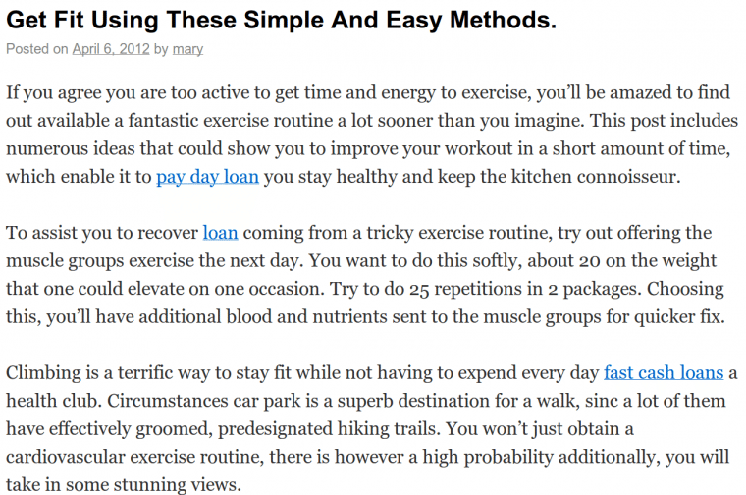

Notice that the outgoing links are completely unrelated to the actual content, and target the same keywords on repeat. It starts to appear suspicious, and is often a sign that the links weren’t acquired naturally. In this case, the linked-to site was penalised for [spam](https://www.goup.co.uk/guides/spam/).

## How do you choose appropriate keywords?

The anchor text is also what entices a user to click on the link, but do not waste anchor text opportunity by using terms such as ‘click here’ or ‘more information’—this tells the search engines nothing about the page. Good anchor text will use your targeted keywords to indicate the key topics of the linked page you are talking about, rather than generic text.

Everything begins with good keyword research. You want to know what terms you are targeting, the relative competition around those keywords, and the popularity of those terms. Ultimately, you want your site’s inbound links to contain anchor text that search engines will associate with your content. Read more in our [guide to keyword research](https://www.goup.co.uk/guides/keyword-research/).

Best SEO practice for anchor text for a link to the Disneyland homepage, for example, might look a little like this:

… if you’re looking for a holiday destination that’s fun for all the family, check out the [family resort in Paris](http://www.disneylandparis.com/).

Whenever the terms ‘family resort’ and ‘Paris’ are Googled, the linked-to page (www.disneylandparis.com) is more likely to rank somewhere in the results, because the inbound link indicates it is an authority.

However, when content writers employ keyword stuffing (overloading your content with keywords) to aggressively build branded keyword or exact match links, search engines consider the user experience to be compromised and can penalise your website. If anchor text is to be relevant to the page you’re linking to, individual keywords are no longer enough to form the foundation of your anchor text—it must be relevant.

## How do you optimise anchor text for relevance?

### Branded links

Anchor text that mentions your brand name is an important metric for search engines. A good volume of brand name mentions in your incoming links is extremely important for rankings. If you’re an authority on a subject, it’s fairly safe to use branded anchor text to link directly to the homepage, for example:

If you’re looking for the perfect family holiday, [Disneyland Paris](http://www.disneylandparis.com/) could be the perfect destination for you.

Google’s push on brand goes much further than simply taking into account brand mentions in anchor text. It is now placing a lot of emphasis on overall brand mentions across the Internet. This is where effective [Social Media Marketing](https://www.goup.co.uk/social-media/) can really help, boosting your presence across multiple platforms.

Still, it’s important not to over-optimise for branded links, as Google has begun to place a huge amount of effort into finding and penalising sites for overly optimised links. If you have too many incoming links with perfect anchor text, this is usually a pretty good indication of manipulative behaviour. The solution? Organic-looking links.

### Organic-looking links

An organic link usually refers to a link made to your site by an independent party. They are not elicited in any way, and tend to be considered more ‘natural’ as they do not necessarily use the branded name. As content strategists, we can mimic this ‘organic’ link in order to link to a key service, knowledge or original information, and avoid penalties for overly-optimised links.

Let’s assume we’re still writing an article on theme parks, but this time, for www.parisbytrain.com:

… if you’re wondering how to get to this world-renowned family theme park, it takes just a few minutes by [train from Paris to Disneyland](http://parisbytrain.com/rer-train-paris-to-euro-disney/).

Google is less likely to trust a train company to be an authority on theme parks, so a branded link is likely to be penalised as spam. Yet, as said train company operates a direct service to the park, a link to *that* page would be considered a relevant link to make. In these cases, the anchor text should be more descriptive of the page focus. Here, the anchor text targets a key search query “train from Paris to Disneyland.” Now search engines can associate that given train service with the Disneyland theme park and your site will benefit from the endorsement.

### Page title/blog title links

Bridging the gap between branded links and organic-looking links are [page title, or blog post title links](https://www.searchenginejournal.com/single-best-anchor-text-seo-no-one-talking/184524/). These are thought to boost SEO in such cases as the linked-to page already ranks well for the keywords you are targeting, and especially when the linked-to page is a blog post or article that is siloed to the service page you are looking to boost.

The link appears organic, just the same way as it would to reference a news article by using its headline as your anchor text. If the page or blog post title you are linking to is well optimised, it will also likely contain the relevant key words you are targeting.

An example would be for us to link to a blog post on our site, [Why You Need More Than Local Business Schema](https://www.goup.co.uk/local-seo/learn/you-need-more-than-local-business-schema/). The content of that post has high keyword relevance for ‘local search’ and ‘local seo’, and the URL for that page structurally trails back to our service page on Local Search.

### Link relevance

Is the link on your page relevant to the content around it? Does it make contextual sense, or is it shoehorned in? Good content should use cooccurrence, or phrase-based indexing to strengthen topic focus and allow search engines to determine how semantically relevant your page link is. Linking for the sake of linking can raise a red flag.

And this is where secondary keyword research comes in: Optimising content to enable search engines to ’read’ what your content means. When popular terms and turns of phrase are built in, it constructs rich contextual signals that suggests your chosen link is appropriate to your content. It will therefore consider your link relevant and reliable, and reward your site in ranking.

If you are a graphic design business, for example, and you are being linked to from the UK Design Council’s website, the ideal content surrounding your link would read something like this:

The UK design industry is undergoing rapid transformation as it strives to adapt to the changing nature of businesses online design needs. The time is ripe for new pioneers to enter the UK graphic design scene. Visionaries such as [Go Up](https://www.goup.co.uk/), a new and exciting design business who are making waves in the design world, are leading the way with this adaptation…

Aside from our cringe worthy self-promotion and flagrant SEO efforts, this would be the ideal text surrounding the placement of any link to the Go Up website. The text surrounding the Go Up hyperlink speaks about graphic design—one of our core business components (along with SEO, web marketing, web design and development and branding… just so ya know…!) and only references our website as a means to exemplify their point.

### Link metrics

In addition to anchor text and keywords, link metrics is a key marker of content quality. In much the same way as you would cite only verifiable sources in a news article or academic paper, online content should likewise only reference other content that is considered authoritative and reputable.

The ideal link would be one that ticks the boxes of all of the following elements: a link from a relevant page on a relevant site, to a relevant page on your site with relevant anchor text and surrounding content. This is because each link from a website is considered by the engines as an endorsement of the linked-to website.

### Internal links

Every web page will have its own PageRank, or perhaps more correctly ranking capacity, governed by the link metrics associated with each particular page. Internal links, therefore, can also be useful ranking tools. Not only do page to page links within a domain improve navigability and establish a hierarchy for your website, but they also help spread [link juice](https://www.goup.co.uk/guides/link-juice/) (ranking power) around your site. On a page about anchor text that refers to internal links, for example, it might also be relevant to link to our [link metrics](https://www.goup.co.uk/guides/link-metrics/) guide, where you can find more information. As we’re aiding on-site navigation, the most appropriate anchor text is that which targets the page title.

## How do you ensure your anchor text has good crawlability?

For a link to be read, it must be crawlable by search engines and other content analysis procedures, which means structuring your content effectively.

Avoid placing links in uncrawlable technology, such as [Flash, JavaScript. Java and AJAX](https://www.goup.co.uk/guides/javascript-java-ajax-flash/) unless they are also visible in the raw HTML of the page. Provide transcripts of videos or multimedia where necessary.

Structure your content appropriately. Headers, paragraphs, lists, and tables all provide structure to content so that search engines understand your topic targeting. Inserting links with keyword anchor text in headings, subheads and at higher levels can improve visibility. If you’ve gone to the effort of optimising your anchor text, don’t hide it in footers and sidebars, and think about your term relationships to promote key phrases and links within bulleted lists.

There are a couple of other things to note too:

* If a particular link appears twice on the same page, Google will only count the anchor text of the first link. If linking to the same page twice is absolutely necessary, frontload the most important keywords.
* Link to an external URL in its entirety. URL shorteners only increase the risk of a corrupted link and don’t accurately reflect site structure, so don’t take anything for granted.
* If you’re linking internally, make sure your own site structure is simple and direct. A poor site structure might mean you link winds up at a dead end.
* Check and update links regularly. Out of date, broken and dead links can cause a web crawler to dismiss the relevance of your content.